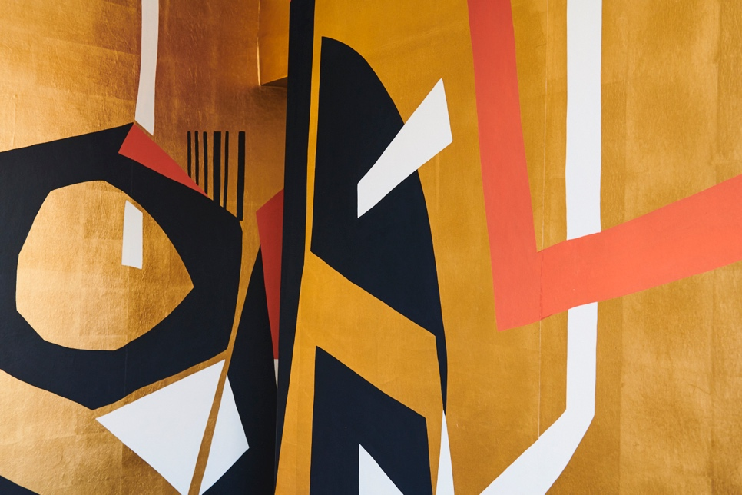

SAMAMBAIA
By Maresca Interiors and Fromental

Piazza San Marco 1, Galleria Pace
9-13April 2019
Press preview: 8 April 2019

For Salone del Mobile 2019 London based interior design studio Maresca Interiors in collaboration with British wallcovering atelier Fromental present the exhibition Samambaia.

Art directed by the Maresca sisters, the exhibition will feature the latest iterations of the company’s collaborative wallpaper Raw, a selection from the Maresca Interiors Brazilian Modern tapestries and furniture collection and the latest designs from their recently released indoor/outdoor collection Lito.

Raw was conceived as the centrepiece for the Fuorisalone 2018 Meandros exhibition and created a powerful impression and a sensory overload, which fully immersed the viewer in the design. Inspired by modern Brazilian tapestries, Fromental shows a truly original custom design using bold shapes hand painted onto brushed artist’s linen. The variety of brushstroke combinations and contrasts gives volume and form to a space which results in a visual tour de force. The collection features bold combinations of sophisticated urban colours, bold metallic shades and organic textures so that the uncensored aesthetic of Raw’s timeless modern design results in a powerful, suggestive and expressive piece of art that can be wrapped around the walls.

Fromental’s Tim Butcher says: “The primal nature of the installation RAW resonated with so many people, the wallcovering just had to be developed further. It has been an exciting process. The strength of the geometric design, inspired by Brazilian cultural art forms renders so differently in each colourway and material combination. This stunning pattern will dramatically transform interior settings, as designers reinterpret Raw for their client’s projects.”

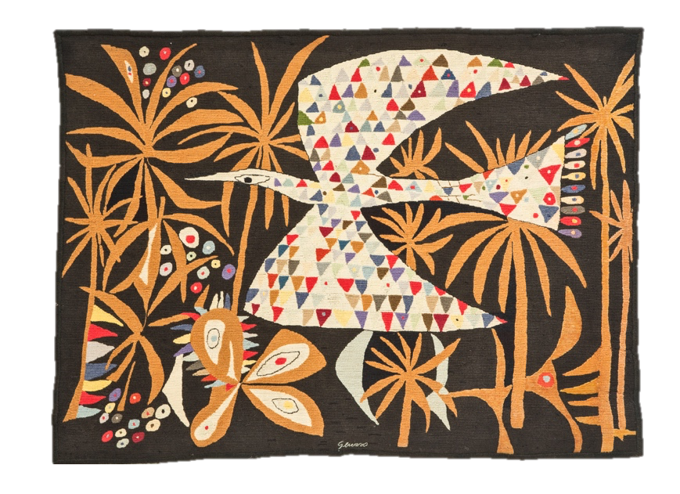

Cecilia from Maresca Interiors says, ‘We admire Fromental incredible craftsmanship and the way they are able to transforms walls into works of art with their beautiful timeless wall coverings. Continuing on our mission of promoting Brazilian Design, with this collaboration inspired by our modern tapestry collection, we magnified, twisted and created a design so magnificent and powerful that the viewer is immediately immersed in it. Yet, with the use of sophisticated palettes, organic textures and bold metallic, the collection is a statement of style’.
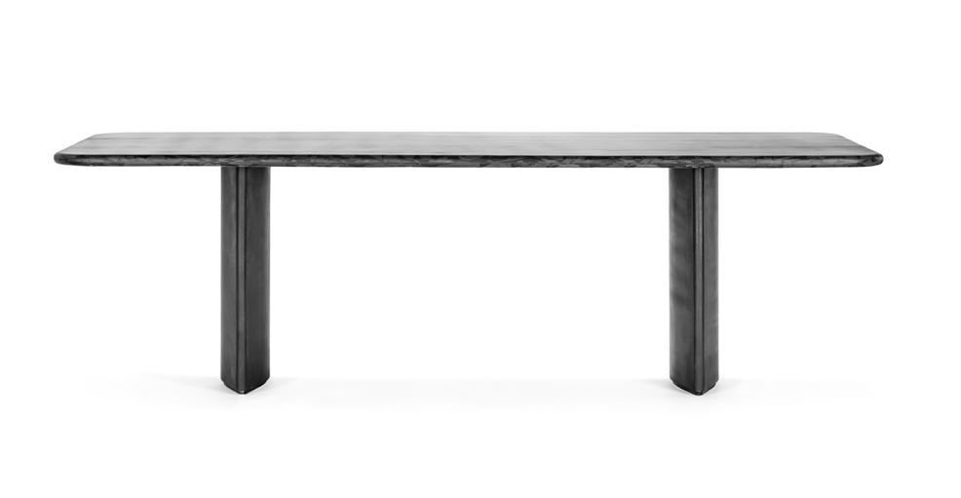
Driven by a timeless visual aesthetic and fuelled by the desire to merge innovation with functionality
and sustainability, Maresca Interiors alongside a selection of Brazilian Modern pieces, present also its latest venture into the world of furniture design: Lito, a versatile collection of high-end design pieces that can be used for both indoor and outdoor. Combining the very best of Italian manufacturing with unpretentious organic colours and natural shapes, Lito is a collection compatible with both classic and contemporary interiors, which can naturally blend into any landscape setting.

NOTES TO EDITORS

ABOUT FROMENTAL
Fromental is a British, award-winning wallcoverings atelier. With showrooms in each major territory, Fromental creates unique works of art for their clients. Each handmade panel demonstrates their distinct creative style. Designed in London and brought to life by skilled craftsmen in China, Fromental brings an inspirational design edge to traditional decorative arts, to create modern, yet timeless wall coverings for the luxury interiors market.

ABOUT MARESCA INTERIORS
Established in 2016 by Italian-Brazilian sister duo Cecilia and Elena Maresca, Maresca Interiors is an interior design and antiques dealing studio based in London. The studio specialises in designing, directing and implementing interiors for residential houses, as well as sourcing Brazilian modern furniture and producing designer furniture.

For press inquiries, please contact:

FROMENTAL
Victoria Murray
Victoria@fromental.co.uk
+ 44 (0) 7714 765367

